Ministry of Health and Family Welfare, Govt. of India
eHealth Section
Nirman Bhawan, Maulana Azad Road
New Delhi - 110011
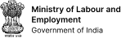

https://esanjeevani.mohfw.gov.in/

